**problem**

People depend on the GPS system in their lives to a great extent

One of its disadvantages is that it only works in open spaces

It does not work in closed places such as buildings and shops

**Introduction**

In covered buildings in order to know where you are located

The mobile phone receives a set of WiFi signals

The signal weakens the further away from the transmitting point it becomes, and the stronger it becomes when approaching it

In this database there are 4 rooms and Wi-Fi signal values for 7 access points obtained while moving inside the rooms

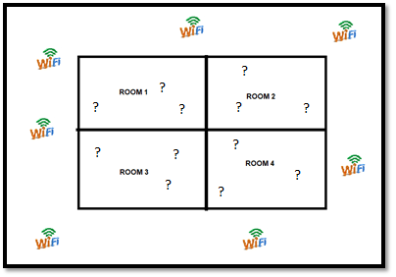

**Pre processing**

* The dataset is txt file content 2000 row and 8 column Every value speared by ( \t ) = tabulation
* 7 columns of single WiFi values in unity called DB between 0 and -100

### 1 column of room number = {1,2,3,4} this means that is multi class classification

* Not exist features names

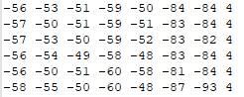

* **For convert this file to csv file We used this code**
* 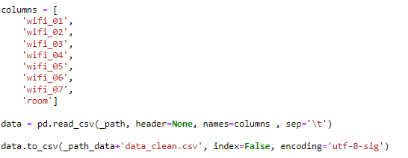

Result of this is



* **One-Vs-Rest for Multi-Class Classification:**

In order to make a classification, we need to convert this multi-class classification problem into a binary classification We now create 4 model every model read data set OVR and return Theta

This 4 Theta used for new classification

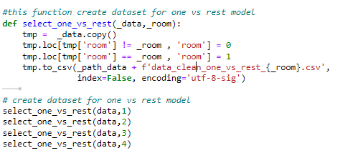

Result of this is 4 files

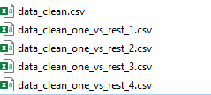

Default class of files (data_clean_one_vs_rest_1.csv) Is room 1 equals 1 and others rooms equals 0

Default class of files (data_clean_one_vs_rest_2.csv) Is room 2 equals 1 and others rooms equals 0

Default class of files (data_clean_one_vs_rest_3.csv) Is room 3 equals 1 and others rooms equals 0

Default class of files (data_clean_one_vs_rest_4.csv) Is room 4 equals 1 and others rooms equals 0

* **Normalization**

All values of signal Wi-Fi convert between 0 and 1



